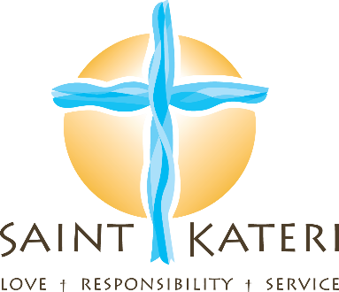

Frequently Asked Questions

- Do we need to contact the Church to plan the funeral liturgy (Mass)?
A representative from the parish will be calling you to set up a meeting to choose the readings and music. Readings will be chosen from sacred scripture.

- What about music?
Please refer to the enclosed document, “Music Within the Order of Christian Funerals.”

- Is there a fee?
If you are using a funeral home, it is included in their fee and they will pay Saint Kateri. If you are not using a funeral home, the fee is $300.00 and includes: the Church, Presider, and Musicians.

- Can we have family members and friends participate in the Mass?
They can participate as: Lector (Reader) - (First Reading, Second Reading and the Prayer of the Faithful) and as Gift Bearers (2-4 people)

- Does Saint Kateri Parish provide a worship aid or program?
Though we do not provide a program, we would be glad to provide you a template to assist you in creating one.

- How do we show proper respect to our loved ones cremated remains?
The cremated remains of a body should be treated with the same respect given to the human body from which they come. This includes the use of a worthy vessel to contain the ashes, the manner in which they are carried, the care and attention to appropriate placement and transport, and the final disposition. The cremated remains should be buried in a grave or entombed in a mausoleum or columbarium. The practice of scattering cremated remains on the sea, from the air, or on the ground, or keeping the cremated remains in the home of a relative or friend of the deceased are not the reverent disposition that the Church requires. Whenever possible, appropriate means for recording with dignity the memory of the deceased should be adopted, such as a plaque or stone which records the name of the deceased. (Order of Christian Funerals, Appendix, Introduction, 417)

