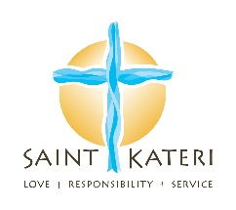

All are welcome!
Alpha for Mature Adults
Fridays, NFC/St. Cecilia 11:30 AM
Alpha is designed to encourage conversation and explore our Christian faith in a friendly, open and informal environment. Light lunch, video and a group discussion.
Is There More to Life Than This?
Beyond ALPHA - Prayer, Simple and Profound
Sundays, 12:00-2:00 pm SMM/DR
We believe everyone should have the chance to
explore the Christian faith, ask questions and share their point of view.
Alpha for Adults - 18+
Sundays, 12:00 pm to 2:00 pm - St. Margaret Mary
Food, Talk, Conversations.
A chance to explore the important questions about life and faith in a non-judgmental setting.
A great way to build community with others!
What is Alpha?
Alpha is for people who have had no formal contact with church as well as those who want to deepen their faith in a supportive, open, informal setting.
Alpha is about meeting people where they are, engaging them in conversations about life’s important questions, introducing them to the person of Jesus, and ultimately helping them build a relationship with Jesus, one another and the Church. While we are hosting it at Saint Kateri, we are using the ecumenical Alpha program and there is no pressure for people to join our or any church.
Contact:
georgiana.bondi@dor.org
Mark.keller@dor.org

