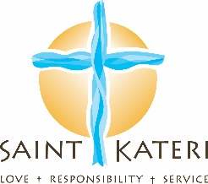

Catechesis of the Good Shepherd coming this Fall to Saint Kateri Parish for 3-6-year-olds

What is the Catechesis of the Good Shepherd?
“Catechesis” is Greek for "echo the teaching" meaning that teaching our faith is an interactive process between the Word of God, the one receiving the message, and the Holy Spirit. Jesus is the Good Shepherd because He laid down His life for his children. He takes care of them. He knows them. They know Him.
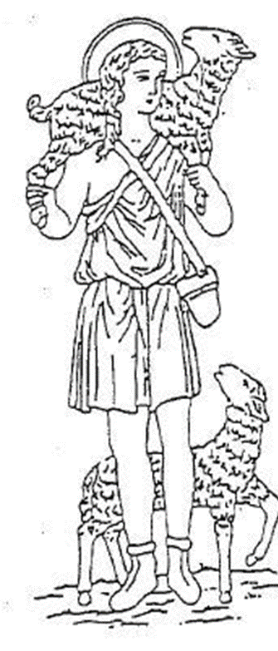
Catechesis of the Good Shepherd (CGS) is based on Montessori principles that enable children to learn through their own discovery using tactile, kinetic, aural, and visual materials and activities. Inside a dedicated space at Christ the King Church, called the Atrium, catechists guide the children to move about to different stations and explore the Word of God. In a contemplative, calming manner, which children of this age desire and need, kids discover Jesus.

Who is this program for?
There are three levels to CGS. This Fall at Saint Kateri Parish, we will be offering Level I which is for the youngest age group, 3-6 year-olds. These young souls are sponges eager to learn and discover God.

Where will CGS happen?
What was previously the parish library at Christ the King Church has been transformed into the Atrium. Children will meet outside the Atrium to prepare to enter the Atrium together. Parents can pick their children up at the Atrium.

When is CGS?
CGS will be offered every Sunday (except school holidays) from 10:45 AM-12:00 PM from October until June. The CGS schedule will follow the school schedule.

What’s the benefit?
Support your child on a life-long relationship with God. Give your child a bedrock of faith to get them through life’s difficulties. Form your child’s identity of themselves as a loved child of God with gifts and purpose. Help your child develop friendships with children of the same faith, same world view, and same values. Develop relationships between your child and the community of our faith family. Provide a peaceful place for your child to explore God. Instill discipline and a sense of reverence in your child. Make Mass relevant to our youngest parishioners by connecting Mass rituals to activities in the classroom. As your child grows in love and in knowledge of God, so will you. Families grow towards God as the children share their experience at home.

What’s the cost?
The cost for the 2019-2020 school year is:
First Child...$50
Second child...$30
Third child...$20

Page 1 of 2

No family will be turned away because of cost. Please contact our office if you have a hardship.

Two of my children (3 and 6) have been attending the Atrium for less than 6 months, but their joy and faith has just grown incredibly. . . my 3 year old told me two days ago: “Mummy, let me tell you about God: God is a miracle because He died on the cross . “In her simple words it was clear to me that she could grasp Christ’s passion and resurrection in a way that we would not expect of a 3-year-old. She also named God as “God is Spirit . . . God is Father . . .” She led me in a discussion on the Trinity! This is the work of the Catechesis, that the children will encounter God, Love Him and that the faith will take root in their hearts and grow, and remain!
--- Bernadette, CGS parent

For Parents:
While the children experience the Atrium, parents are invited to stay and join in food, a talk, and casual conversation to explore the important topics of life and faith. This will be an informal session geared toward parents to encounter friendship and explore their own relationship with Christ. #TryAlpha

To Sign up, visit: https://bit.ly/2P75j3u

For more information, contact:

Jessica Tette
Coordinator of Children's and Youth Ministries
Saint Kateri Parish
445 Kings Highway S.
Rochester, NY 14617
(585)544-8880 ext. 3411
jessica.tette@dor.org

Page 2 of 2

