Creating a Safe Environment Online Training Instructions for Adults
All adult volunteers working with children, youth, or vulnerable adults need to complete the same training—whether they are new, renewing after 3 years, working with children/youth, or working with vulnerable adults. In-person training remains an option, and it is the only option for teen volunteers.
Introduction: The online training only works using Chrome as your Browser. The Chrome Icon looks like this:
There are 5 courses in the training:
1. Meet Sam
2. It Happened to Me
3. Exploitation in Elder-Serving Programs
4. Abuse Risk Management for Volunteers
5. DOR policies – Volunteers The first four courses include ‘Action Plans’. These are for your enrichment. You may choose to print them or not. If you open an action plan, simply close it’s tab at the top to return to the training.
To Access the training: In the address bar of the Chrome web browser, type in the address www.dor.training Click on “Creating a Safe Environment 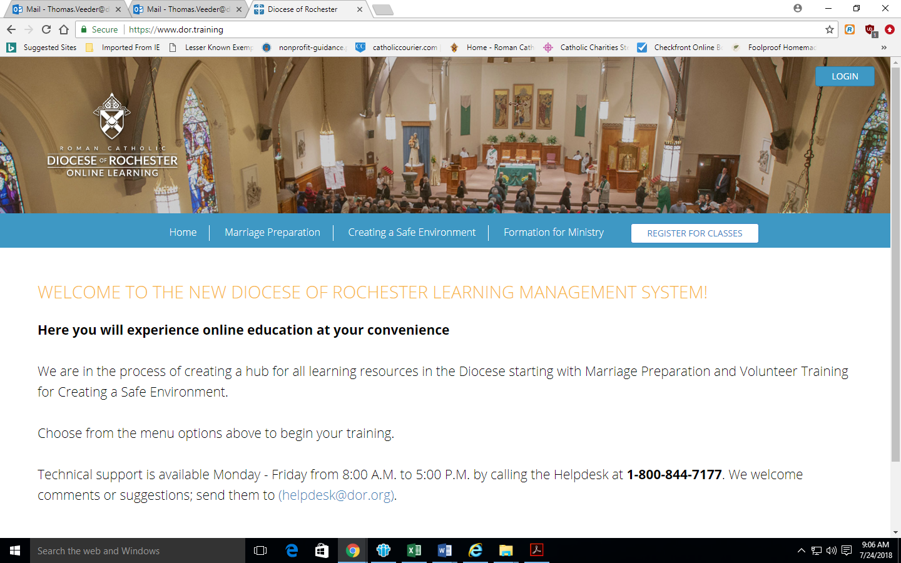
- Scroll down to select the English or Spanish version and click on “Register Now”
- Click on “Add to Cart”
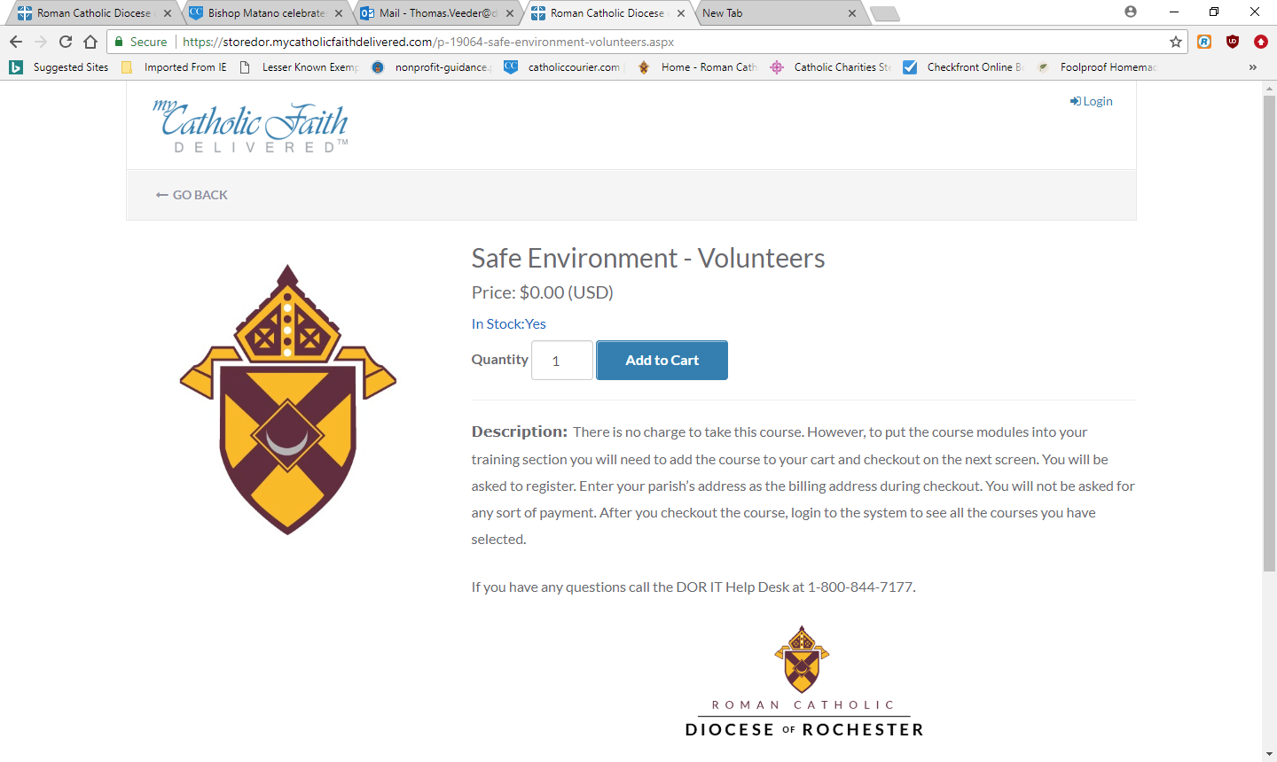
- Click on “Checkout”
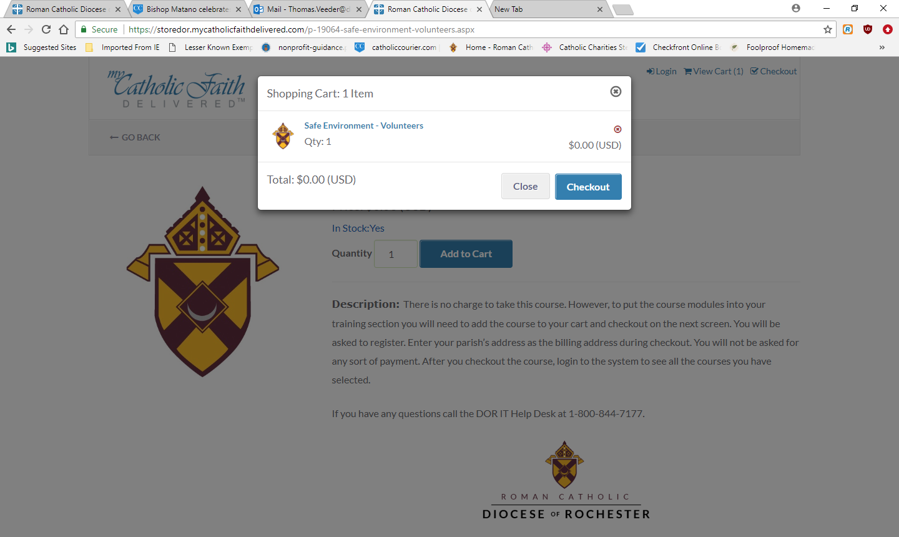
- Enter your email address and click “Save”
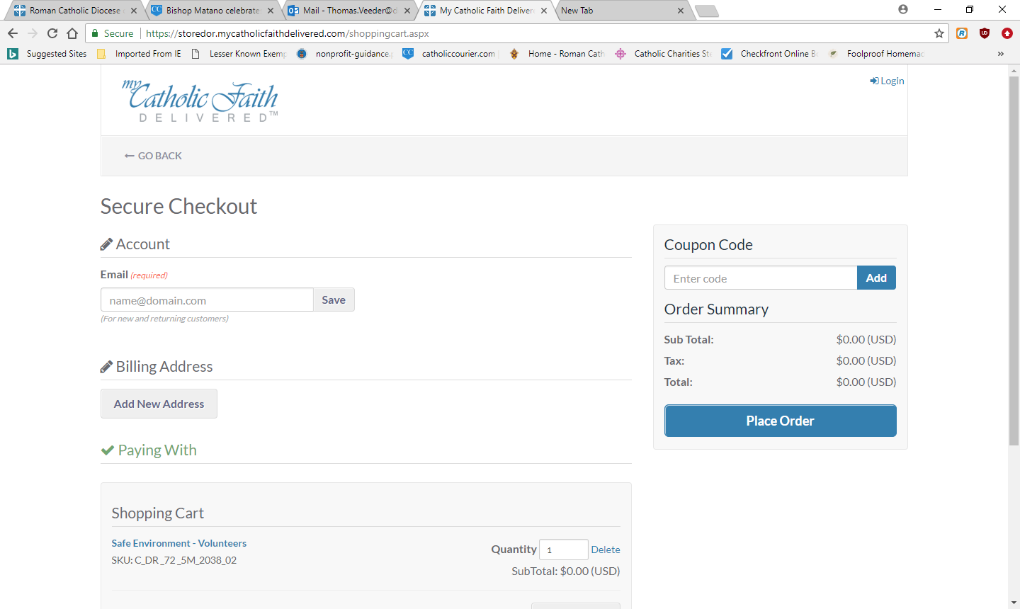
- Enter a password and click “Create Account” if this is your first time.
Your password must be between 8 and 20 characters. It must include at least 1 uppercase letter, 1 lowercase letter, 1 number, and 1 special symbol (# $ % ^ & * @ ! ~ are acceptable).
- Click on “Add New Address.”
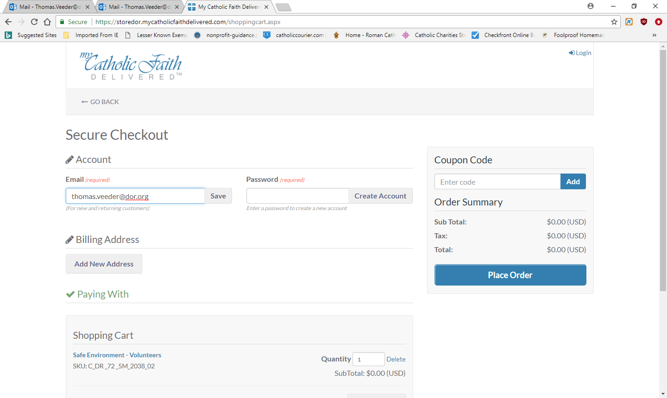

- Enter your name and the address of your Parish/School/Ministry. Remember there will be no cost for this training.
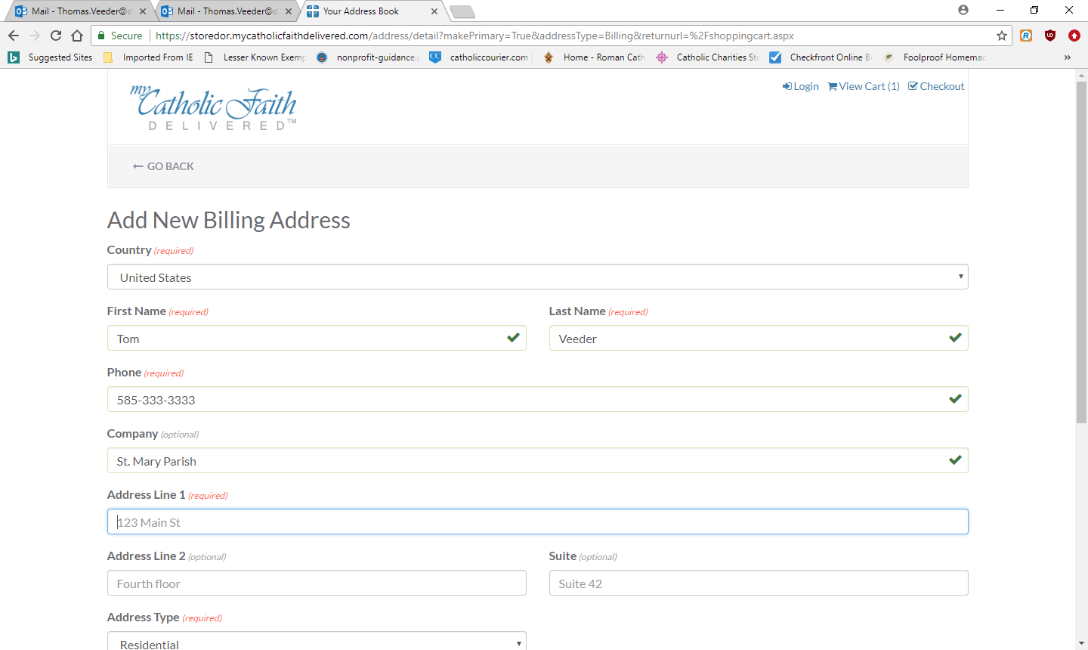
- Click on Place Order
Note: This setup in lengthy but you will only need to do it once.
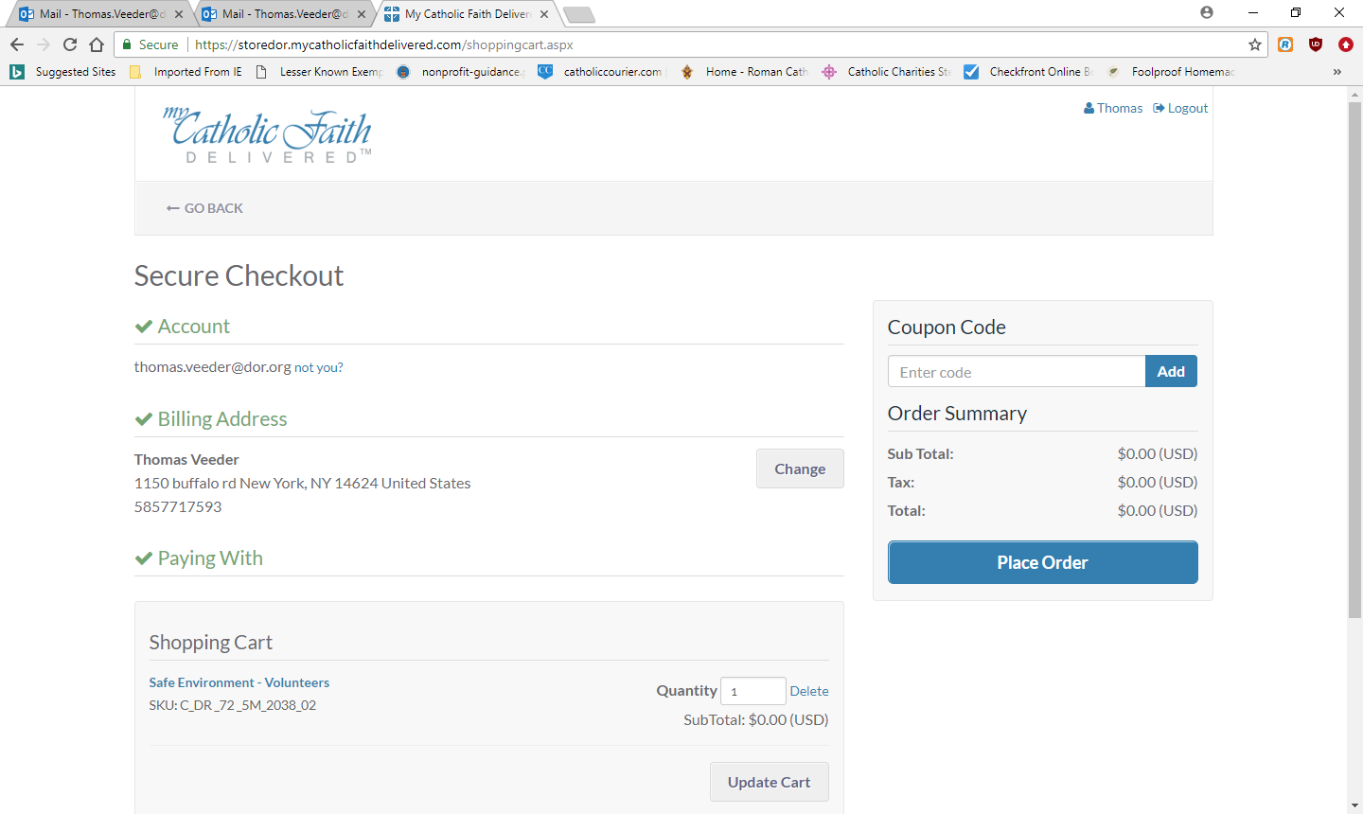
- You do not need to print the receipt since there is no cost. Some other trainings require payment. Safe Environment does not.
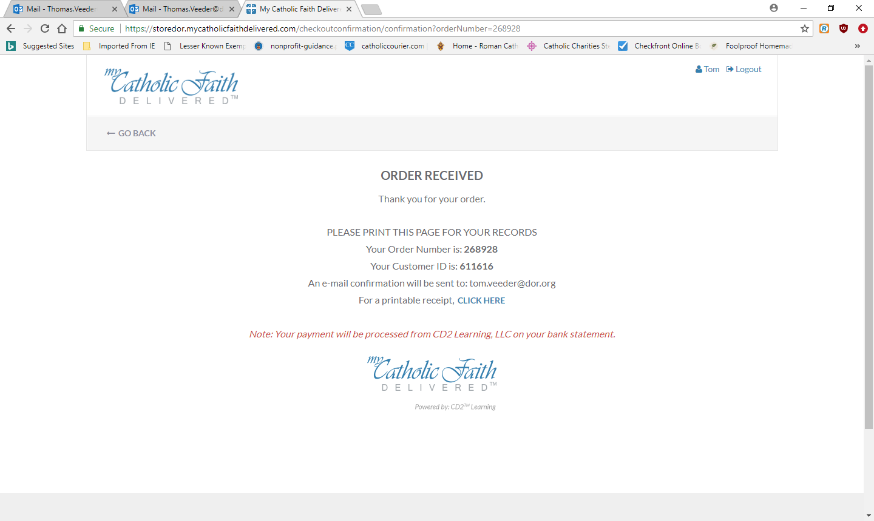
- Close everything and open a new browser. Do the following any time you want to re-enter your safe environment training. Enter www.dor.training to get to the original screen.
- Choose “Login” in the upper right hand corner to access your courses.
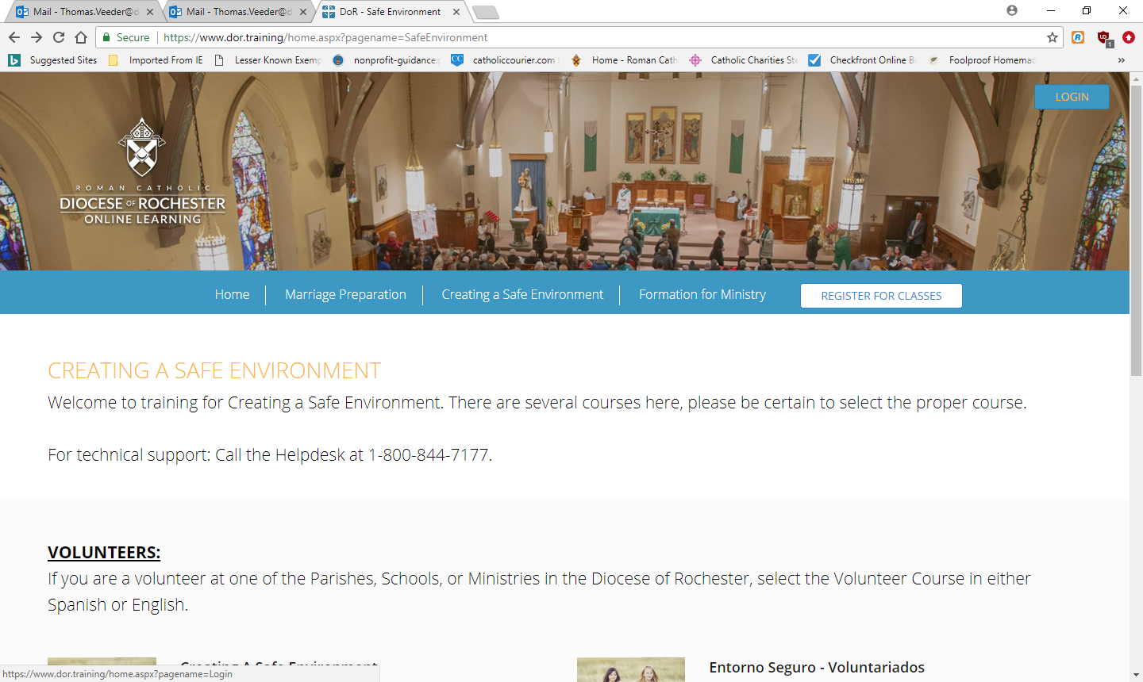
- Enter your email address and the password you just created.
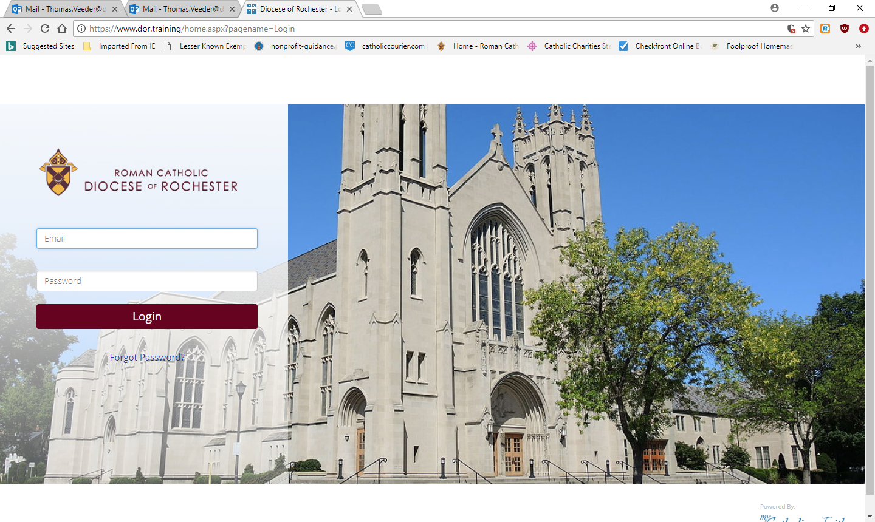
- You will be asked to select your parish/school/ministry.
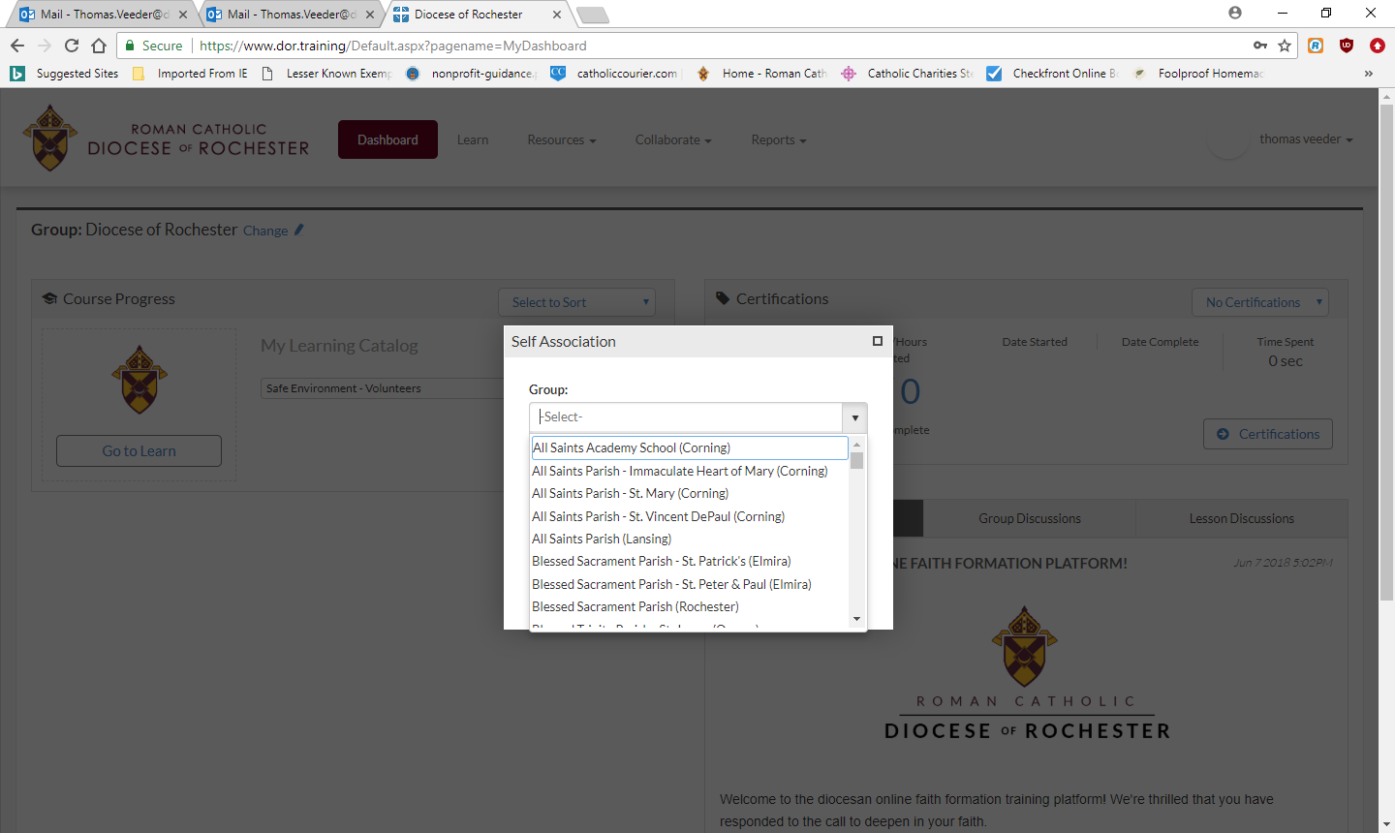

- Click on “Go to Learn” to begin your training.
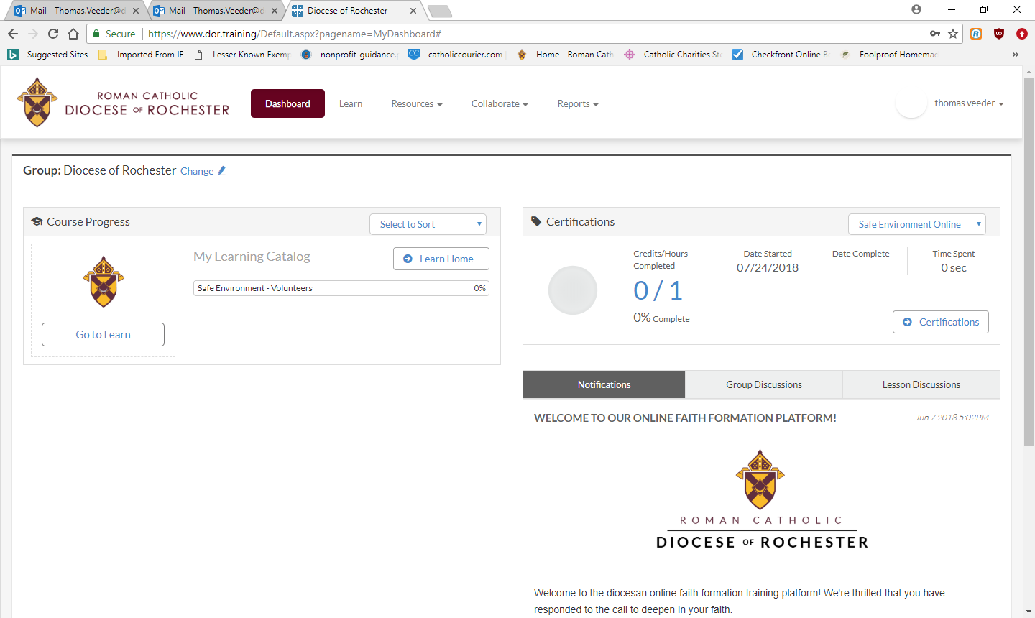
Notes:
You must complete all 5 parts of the safe environment training for volunteers. Please do these in order. Each of the first four courses ends with quiz questions. To go to the next course, click the button that says “ return to activities” in the top left-handed corner.
You may stop and log out between courses.
When you have completed all 5 parts, please print your certificate and give a copy to your parish/school Creating a Safe Environment Coordinator.
If you have any difficulty, please call the CASE Coordinator, Corynn Shaw Monday – Friday from 8:30 AM – 2:30 PM for assistance at 585-544-8889 Ext 3403
Thank you for your ministry!

